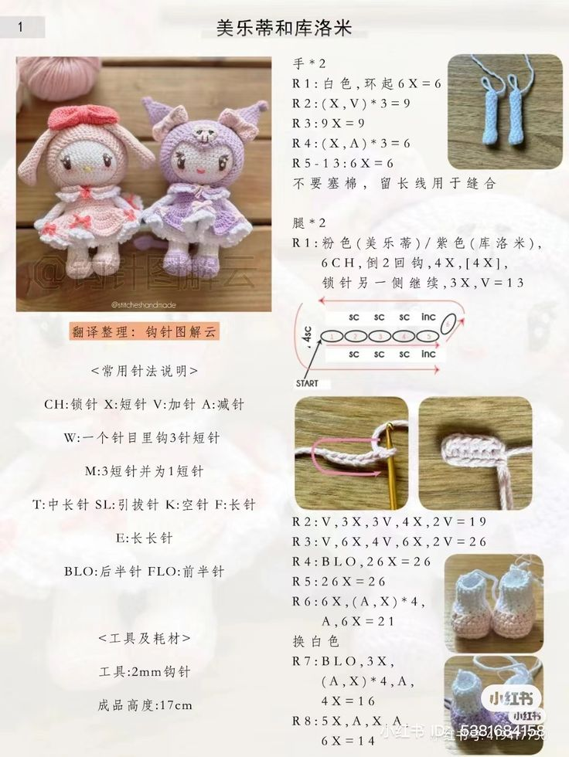
https://br.pinterest.com/pin/pin-von-cony-phm-auf-mc-len--1337074886980418/
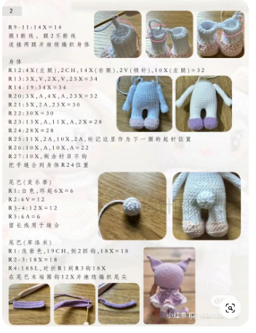
https://br.pinterest.com/pin/299137600268477448/
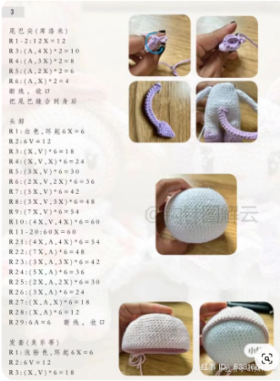
https://br.pinterest.com/pin/93660867244861034/

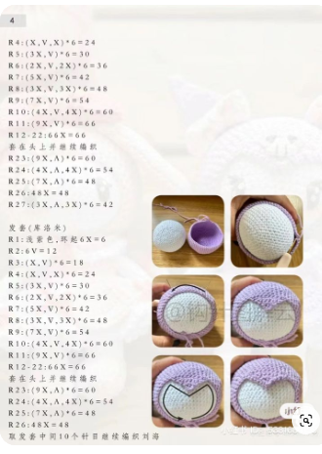
https://br.pinterest.com/pin/93660867244861029/
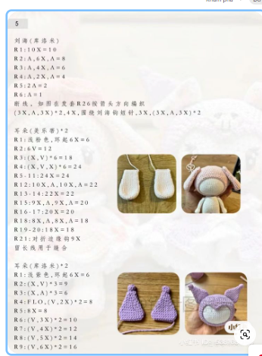
https://br.pinterest.com/pin/93660867244861031/
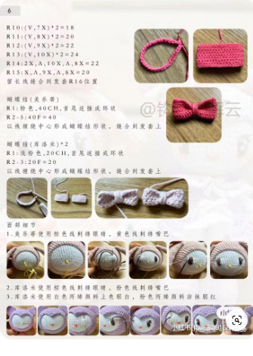
https://br.pinterest.com/pin/93660867244861035/
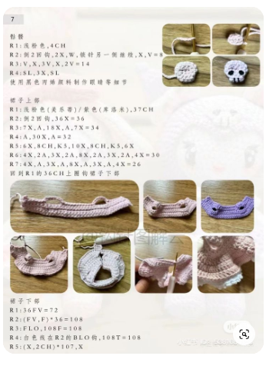
https://br.pinterest.com/pin/295548794317116450/
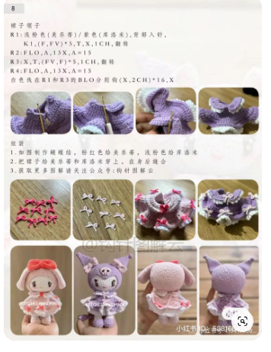
https://br.pinterest.com/pin/3448137208567261/

